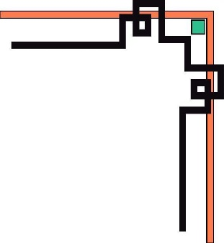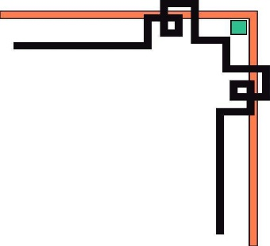

**MINISTRY OF EDUCATION AND TRAINING**

**HCMC UNIVERSITY OF TECHNOLOGY AND EDUCATION**

**FACULTY OF INFORMATION TECHNOLOGY**

----🙦🙦🕮🙤🙤----



**REPORT**

**FINAL PROJECT**

**Coffee management system**

**Instructor: PhD.Le Van Vinh**

*Le Minh Tri – 17110086*

*Nguyen Quoc Thanh - 17110072*

*CLASS: 17110CLA*

**Ho Chi Minh City, July 2020**

**THANKS**



To complete the project, it is essential to have instructors and reference materials. We would like to thank Mr. Le Van Vinh, who provided us with the opportunity and motivation to gain knowledge through classroom learning, and subject-based exercises. We will gain practical knowledge through this project, which will help us a lot in our careers.

The presentation is not free limitation. There might have problem regarding lack of limitation in some aspect, also some minor mistakes sus as typing mistakes. We apologize if any error is found which was deliberately made. Please feel free to contact us if any question arises.

***Thank you!***



**Instructor’s evaluation**

**…………………………………………………..…………………………………………………………………………………………………….………………………………………………….………………………………………………….………………………………………………….………………………………………………….………………………………………………….………………………………………………….………………………………………………….………………………………………………….**

*Ho Chi Minh City, June, 2020*

*Instructor*

*PhD. Le Van Vinh*

**CONTENTS**

***I.*** ***INTRODUCTION*** 1

***II.*** ***REQUIREMENT*** 2

***1.*** ***Actors:*** 2

***2.*** ***Usecases Diagrams:*** 3

***3.*** ***Scenarios:*** 4

***3.1*** ***For Customer:*** 4

***3.1.1 Order:*** 4

***3.1.2 Payment:*** 5

***3.1.3 Normal Customer:*** 6

***3.1.4 VIP Customer:*** 7

***3.2*** ***For Cashier:*** 8

***3.2.1 Make membership card (Normal Customer):*** 8

***3.2.2 Payment:*** 9

***3.2.3 Payment Management:*** 10

***3.2.4 Login (Staff):*** 11

***3.2.5 Menu Management:*** 12

***3.2.6 Promotion:*** 13

***3.3 For Desk Management:*** 14

***3.3.1 Desk Management: (Login Staff)*** 14

***3.4 For Administrator:*** 15

***3.4.1 Administrator: (Login Admin)*** 15

***III.*** ***SEQUENCE DIAGRAMS:*** 16

***1.*** ***Login:*** 16

***2.*** ***Desk management: (Login staff)*** 16

***3.*** ***Order:*** 17

***4.*** ***Administrator:*** 17

***5.*** ***Desk management:*** 18

***6.*** ***Cashier:*** 20

***IV.*** ***CLASS DIAGRAMS*** 22

***V.*** ***COMMUNICATION DIAGRAMS*** 23

***1.*** ***Login:*** 23

***2.*** ***Cashier:*** 23

***VI.*** ***STATE DIAGRAMS*** 24

***1.*** ***Login:*** 24

***2.*** ***Staff management:*** 24

***VII.*** ***COMPONENT DIAGRAMS:*** 25

***VIII.*** ***SUMMARY:*** 25

1. ***INTRODUCTION***

Coffee shop is a place of rest, relaxation and indispensable work in life today.

When customers come to the coffee shop, customers will have a menu to choose. After ordering, customers will come to the cashier to pay. The payment can be made directly by cash or via credit card.

For modern coffee shops, the software will support the information management of loyal customers. These are customers who have a membership card at the shop (requested by the customer). Depending on the VIP level of the customer, the shop will be able to have certain promotions (such as discount when buying products, birthday gifts ...).

At the coffee shopp there will be cashiers. These are the people who have the role of adjusting menu information, adjusting prices. In some cases, the cashier will have to help regulate the management of promotions, tax rates, discounts, etc. In addition, when customers pay for their products, the cashier will have to concurrently manages the creation, repair and invoicing for customers

In a coffee shop, the desk manager will be responsible to join the table, tick the table information to support the management process. When performing these tasks, the desk manager needs to use software to update the table situation as quickly and accurately as possible. Some basic operations: create tables, tick, join tables, split tables, book tables, ...

To manage system users, a coffee shopkeeper has an administrator role. This employee allows to manage system user information. When there is a new employee, the administrator updates the employee information into the system, creates an account and grants employee rights. When the employee information is erroneous or removed from the system, the administrator corrects or deletes the employee's information from the system.

The system user must login before performing the operation authorized by the system administrator.

1. ***REQUIREMENT***
2. 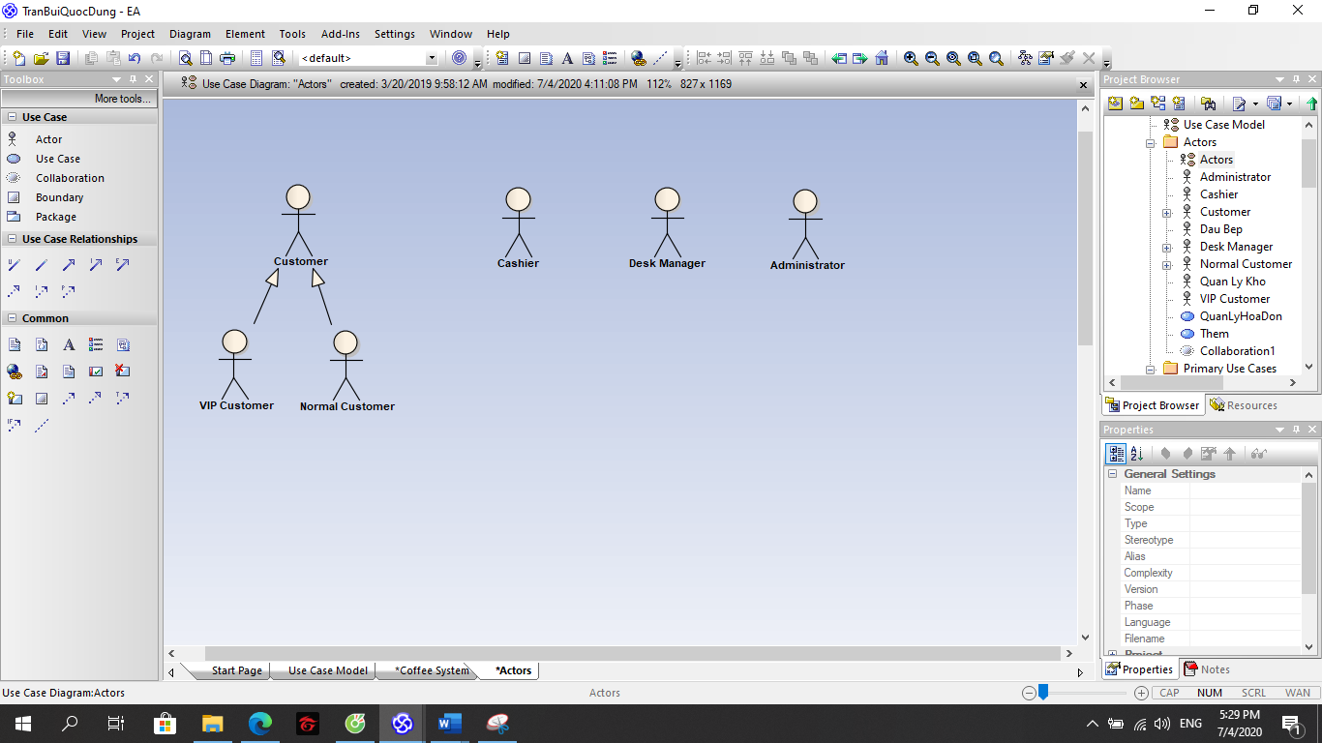***Actors:***

***Figure1. Actors***

1. ***Usecases Diagrams:***

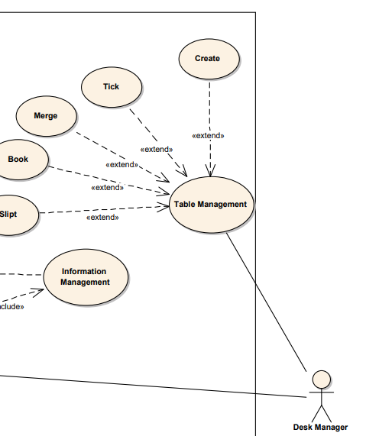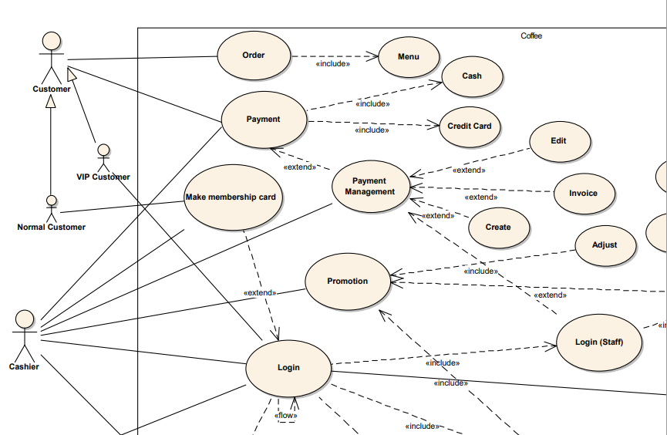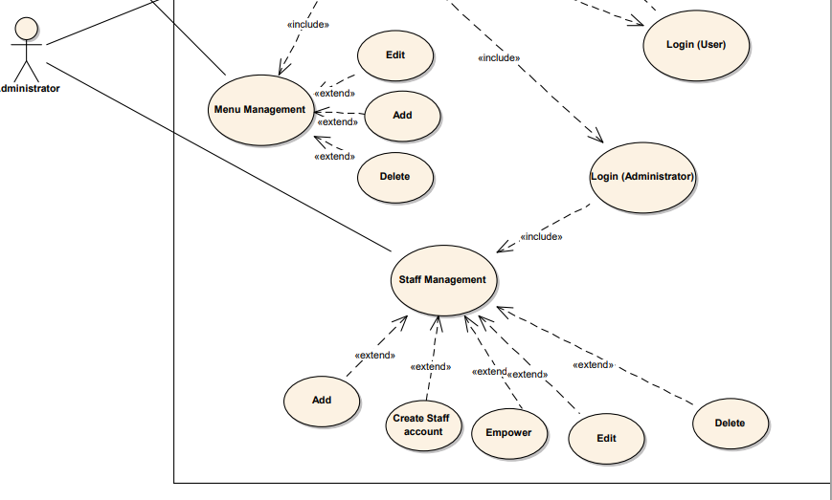

***Figure2. Usecase Diagrams***

1. ***Scenarios:***
   1. ***For Customer:***

***3.1.1 Order:***

|  |  |
| --- | --- |
| **Name** | **Order** |
| **Brief Description** | Customer will allow guests to book online and take away, bill in coffee shop. |
| **Actor(s)** | Customer. |
| **Flow of Events** | |
| **Basic Flow** | |
| Customers ordered.  Customers confirmed.  Staff received customer’s order. | |
| **Alternate Flows** | |
| - Customers do not confirm the order.  - Customers ask for staff’s advice. | |
| **Pre-Conditions** | |
| **Title** | **Description** |
| Choose | Customers have chosen the drink and cake. |
| **Post-Conditions** | |
| **Title** | **Description** |
| Confirmed | Customers confirmed the drink and cake. |
| Choose payment | There are two ways of payment:   1. Pay with cash. 2. Pay with credit card. |
| **Extension Points** | |
| Customers do not order the drink. | |

***3.1.2 Payment:***

|  |  |
| --- | --- |
| **Name** | **Payment** |
| **Brief Description** | Customers have invoices and payments after order. |
| **Actor(s)** | Customer |
| **Flow of Events** | |
| **Basic Flow** | |
| 1. Guest finished order. 2. Guests choose the payment way. | |
| **Alternate Flows** | |
| Guest cannot afford to pay. | |
| **Pre-Conditions** | |
| **Title** | **Description** |
| Order and Confirmed | Guest finished their order and confirmed to cashier. |
| **Post-Conditions** | |
| **Title** | **Description** |
| Pay | Guest have capability to pay. |
| **Extension Points** | |
| Guest refuse to pay. | |

***3.1.3 Normal Customer:***

|  |  |
| --- | --- |
| **Name** | Make membership card |
| **Brief Description** | Customers want to make membership card |
| **Actor(s)** | Normal Customer |
| **Flow of Events** | |
| **Basic Flow** | |
| 1. Customer gives their information. 2. The cashier logs in to the user management system. 3. The cashier creates a new user account. 4. The cashier gives card to customer. | |
| **Alternate Flows** | |
| Customer had membership card | |
| **Pre-Conditions** | |
| **Title** | **Description** |
| None |  |
| **Post-Conditions** | |
| **Title** | **Description** |
| None |  |
| **Extension Points** | |
| Customers do not need to make a card. | |

***3.1.4 VIP Customer:***

|  |  |
| --- | --- |
| **Name** | Login. (User) |
| **Brief Description** | VIP customer logs in web page for user |
| **Actor(s)** | VIP Customer |
| **Flow of Events** | |
| **Basic Flow** | |
| This use case when a customer has VIP customer account and go to the log in page:   1. The system requests the user for username and password. 2. The user enters his/her username and password. 3. The system check username and password. 4. The user is signed in and returned to hoe page as a logged in User. 5. The VIP user can receive promotion notice. 6. The use case end. | |
| **Alternate Flows** | |
| If username or password wrong:  The system announces the user retype username/password. | |
| **Pre-Conditions** | |
| **Title** | **Description** |
| **Post-Conditions** | |
| **Title** | **Description** |
| Success | The user is authenticated and the system displays a homepage. |
| Fail | User is unable to log in for one or more reason. |
| **Extension Points** | |
| None | |

* 1. ***For Cashier:***

***3.2.1 Make membership card (Normal Customer):***

|  |  |
| --- | --- |
| **Name** | Make membership card |
| **Brief Description** | Customers want to make membership card |
| **Actor(s)** | Cashier |
| **Flow of Events** | |
| **Basic Flow** | |
| This use case starts when a cashier logs in web page by use staff account.   1. Customer gives their information. 2. The cashier logs in to the user management system. 3. The cashier creates a new guest user account. 4. The cashier gives card to customer. 5. The use case end. | |
| **Alternate Flows** | |
| Customer had membership card | |
| **Pre-Conditions** | |
| **Title** | **Description** |
| Login (Staff) | Cashier logs in web page by staff account. |
| **Post-Conditions** | |
| **Title** | **Description** |
| None |  |
| **Extension Points** | |
| Guest refuse to pay. | |

***3.2.2 Payment:***

|  |  |
| --- | --- |
| **Name** | Payment |
| **Brief Description** | Customers have invoices and payments after order. |
| **Actor(s)** | Cashier |
| **Flow of Events** | |
| **Basic Flow** | |
| This use case starts when a cashier logs in web page by use staff account.   1. The cashier logs in to the user management system. 2. Guest finished order. 3. Guest chooses the payment method. 4. The use case end. | |
| **Alternate Flows** | |
| Guest cannot afford to pay | |
| **Pre-Conditions** | |
| **Title** | **Description** |
| Login (Staff) | Cashier logs in web page by staff account. |
| Order and Confirmed | Guest finished their order and confirmed to cashier. |
| **Post-Conditions** | |
| **Title** | **Description** |
| Pay | There are two payment methods.   1. Pay by cash 2. Pay by credit card. |
| **Extension Points** | |
| Guest refuse to pay. | |

***3.2.3 Payment Management:***

|  |  |
| --- | --- |
| **Name** | Payment Management |
| **Brief Description** | Cashier directly manages payment (Edit, Create, Invoice) |
| **Actor(s)** | Cashier |
| **Flow of Events** | |
| **Basic Flow** | |
| This use case starts when a cashier logs in web page by use staff account.   1. The cashier logs in to the user management system. 2. The cashier can Edit/ Create/ Invoice bill. 3. The use case end. | |
| **Alternate Flows** | |
| None | |
| **Pre-Conditions** | |
| **Title** | **Description** |
| Login (Staff) | The cashier logs in web page by staff account. |
| Create | The cashier creates new bill. |
| Edit | The cashier edits bill. |
| **Post-Conditions** | |
| **Title** | **Description** |
| Invoice | The cashier invoices bill. |
| **Extension Points** | |
| None | |

***3.2.4 Login (Staff):***

|  |  |
| --- | --- |
| **Name** | Login (Staff) |
| **Brief Description** | Cashier logs in to the web page (Staff account) |
| **Actor(s)** | Cashier |
| **Flow of Events** | |
| **Basic Flow** | |
| This use case starts when a cashier logs in web page by use staff account.   1. The cashier logs in to the user management system. 2. The cashier can see manage information: customer, menu, payment, make membership card 3. The use case end. | |
| **Alternate Flows** | |
| **Title** | **Description** |
| Manage customer. | The cashier can manage customer. |
| Manage menu. | The cashier can manage menu. (Add/ Edit/ Delete) |
| Manage payment. | The cashier can manage payment. |
| Manage membership. | The cashier can manage membership. |
| **Pre-Conditions** | |
| **Title** | **Description** |
| Login (Staff) | The cashier logs in web page by staff account. |
| **Post-Conditions** | |
| **Title** | **Description** |
| Success | The cashier account is authenticated and the system displays a homepage. |
| Fail | The cashier is unable to log in for one or more reason. |
| **Extension Points** | |
| None | |

***3.2.5 Menu Management:***

|  |  |
| --- | --- |
| **Name** | Menu Management |
| **Brief Description** | Cashier directly manages menu (Add, Edit, Delete) |
| **Actor(s)** | Cashier |
| **Flow of Events** | |
| **Basic Flow** | |
| This use case starts when a cashier logs in web page by use staff account.   1. The cashier logs in to the user management system. 2. The cashier can Add/ Edit/ Delete. 3. The use case end. | |
| **Alternate Flows** | |
| Add | The cashier can add new drink. |
| Edit | The cashier can edit information drink. |
| Delete | The cashier can delete drink. |
| **Title** | **Description** |
| **Pre-Conditions** | |
| **Title** | **Description** |
| Login (Staff) | The cashier logs in web page by staff account. |
| **Post-Conditions** | |
| **Title** | **Description** |
| None |  |
| **Extension Points** | |
| Drink already exists or not yet in the menu. | |

***3.2.6 Promotion:***

|  |  |
| --- | --- |
| **Name** | Promotion. |
| **Brief Description** | Cashier update promotion for customer. |
| **Actor(s)** | Cashier. |
| **Flow of Events** | |
| **Basic Flow** | |
| This use case starts when a cashier logs in web page by use staff account.   1. The cashier logs in to the user management system. 2. The cashier update promotion for customer. (birthday, discount) 3. The use case end. | |
| **Alternate Flows** | |
| **Title** | **Description** |
| Adjusted | The cashier can add/ edit/ delete promotion. |
| **Pre-Conditions** | |
| **Title** | **Description** |
| Login (Staff) | The cashier logs in web page by staff account. |
| **Post-Conditions** | |
| **Title** | **Description** |
| Apply | The cashier applies promotion for invoice’s customer. |
| **Extension Points** | |
| 1. Customer do not use promotion. 2. The promotion does not apply simultaneously with many promotions. 3. The promotion expired. | |

***3.3 For Desk Management:***

|  |  |
| --- | --- |
| **Name** | Login (Staff). |
| **Brief Description** | Desk management logs in to the web page (Staff account). |
| **Actor(s)** | Desk management. |
| **Flow of Events** | |
| **Basic Flow** | |
| This use case starts when a desk management logs in web page by use staff account.   1. The desk management logs in to the user management system. 2. The desk management update desk status. 3. The use case end. | |
| **Alternate Flows** | |
| **Title** | **Description** |
| Create | The desk management creates new tables. |
| Tick | The desk management ticks tables. |
| Merge | The desk management merges tables. |
| Split | The desk management slipts tables. |
| Book | The desk management books a table when a customer has booked a table. |
| **Pre-Conditions** | |
| **Title** | **Description** |
| Login (Staff) | The desk management logs in web page by staff account. |
| **Post-Conditions** | |
| **Title** | **Description** |
| Success | The cashier account is authenticated and the system displays a homepage. |
| Fail | The cashier is unable to log in for one or more reason. |
| **Extension Points** | |
| None | |

***3.3.1 Desk Management: (Login Staff)***

***3.4 For Administrator:***

***3.4.1 Administrator: (Login Admin)***

|  |  |
| --- | --- |
| **Name** | Login (Admin). |
| **Brief Description** | Administrator logs in to the web page (Admin account). |
| **Actor(s)** | Administrator. |
| **Flow of Events** | |
| **Basic Flow** | |
| This use case starts when an administrator logs in web page by use admin account.   1. The administrator logs in to the user management system. 2. The administrator can update employee information. 3. The use case end. | |
| **Alternate Flows** | |
| **Title** | **Description** |
| Add | The administrator can update employee information. |
| Create | The administrator can create new accounts for employee. |
| Empower | The administrator can empower for account employee. |
| Edit | The administrator can edit information and empower. |
| Delete | The administrator can delete employee’s account. |
| **Pre-Conditions** | |
| **Title** | **Description** |
| Login (Staff) | The desk management logs in web page by staff account. |
| **Post-Conditions** | |
| **Title** | **Description** |
| Success | The cashier account is authenticated and the system displays a homepage. |
| Fail | The cashier is unable to log in for one or more reason. |
| **Extension Points** | |
| None | |

1. ***SEQUENCE DIAGRAMS:***
2. **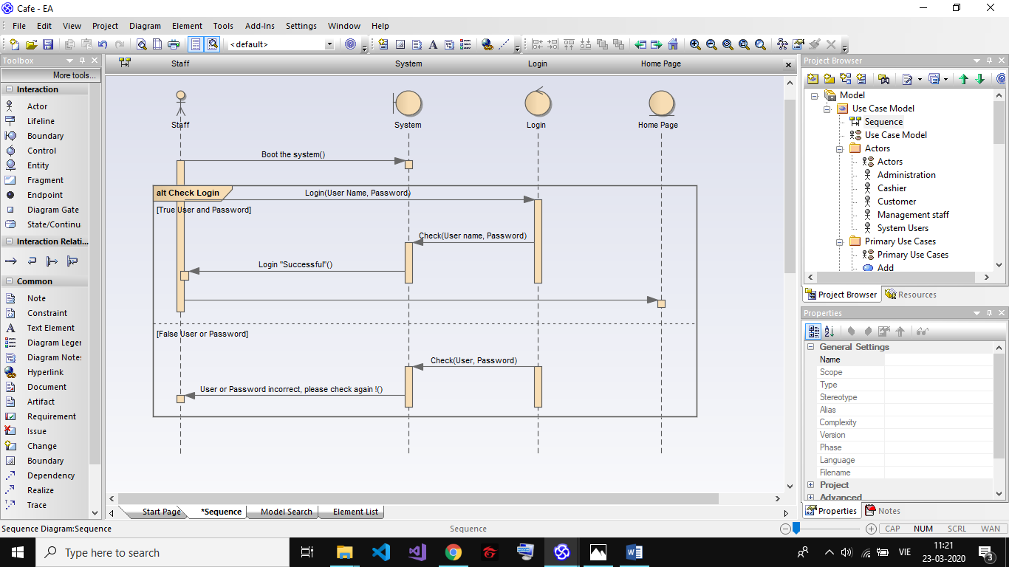*Login:***

***Figure3. Login sequence diagrams.***

1. **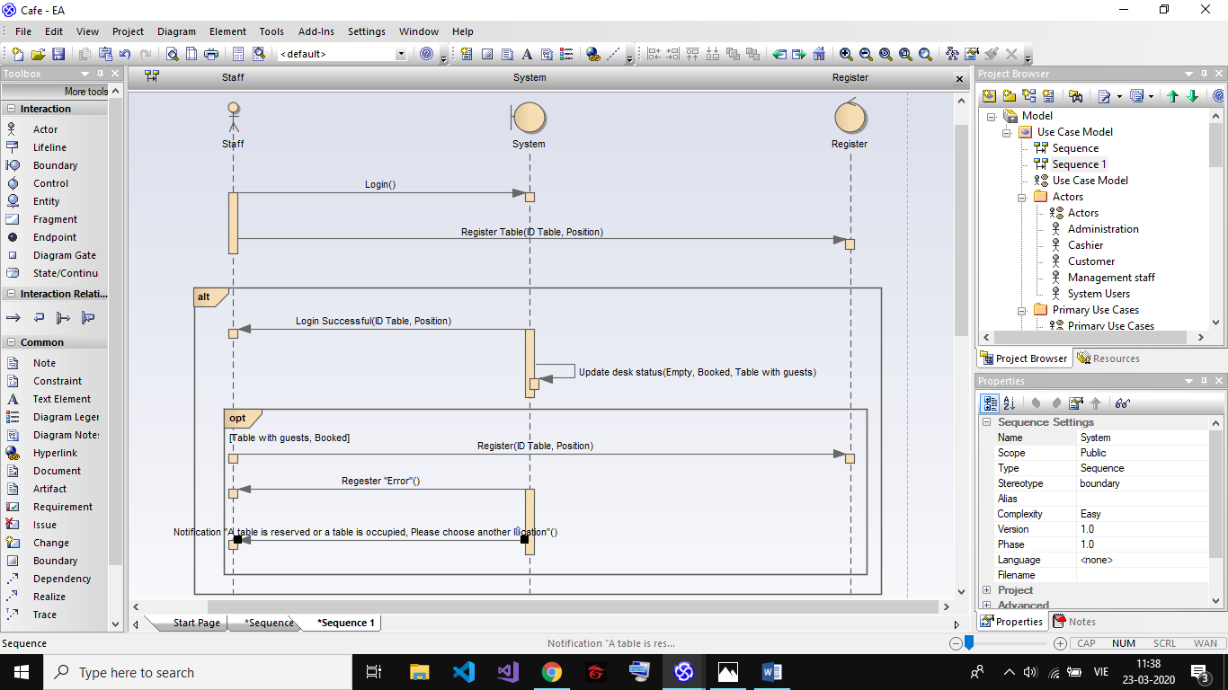*Desk management: (Login staff)***

***Figure4. Desk management (Login Staff) sequence diagrams.***

1. ***Order:***

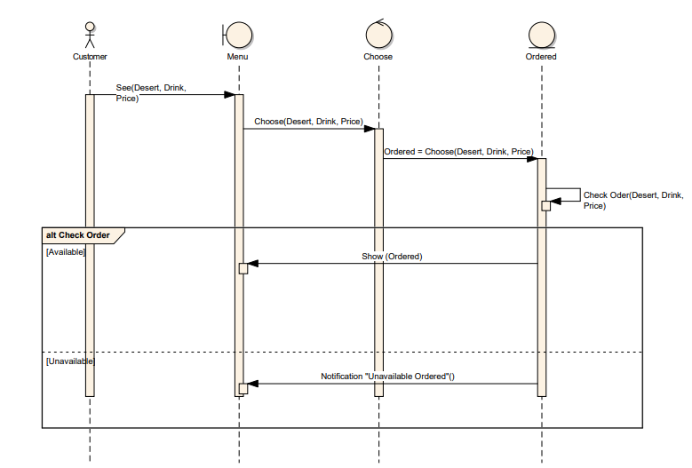

***Figure5. Order sequence diagrams.***

1. 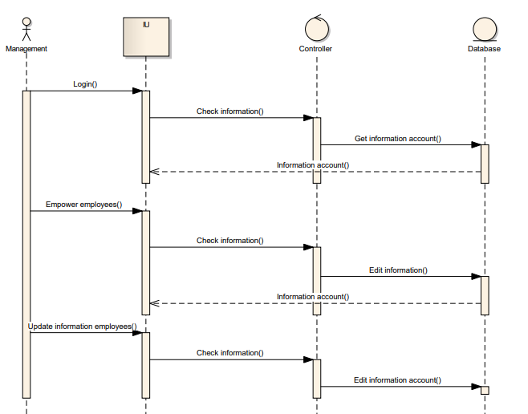***Administrator:***

***Figure6. Administrator sequence diagrams.***

1. ***Desk management:***

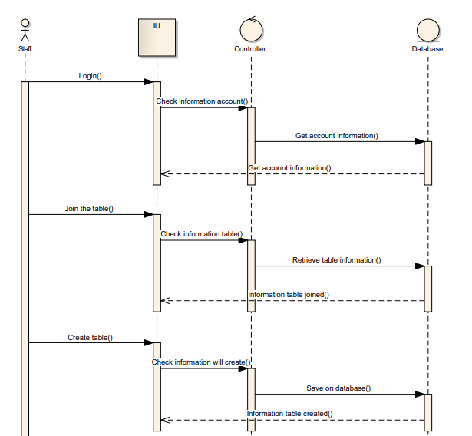

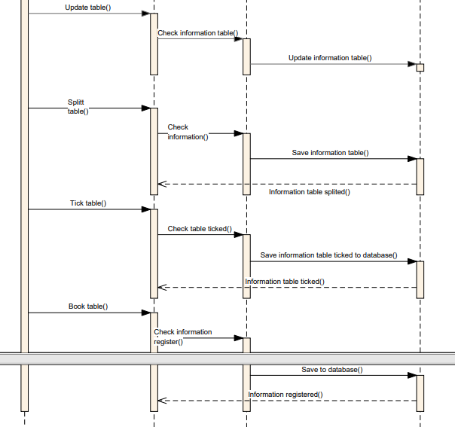

***Figure7. Desk management sequence diagrams.***

1. ***Cashier:***

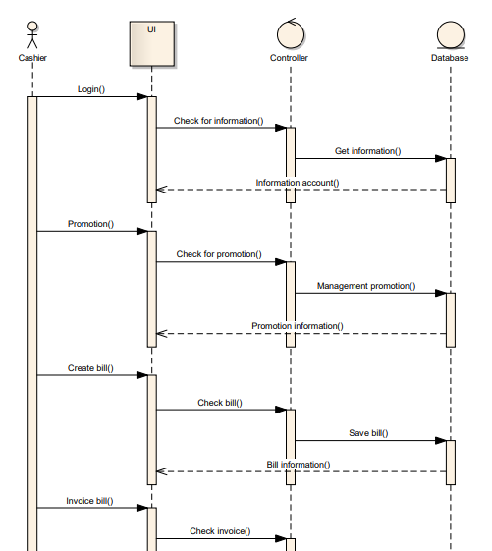

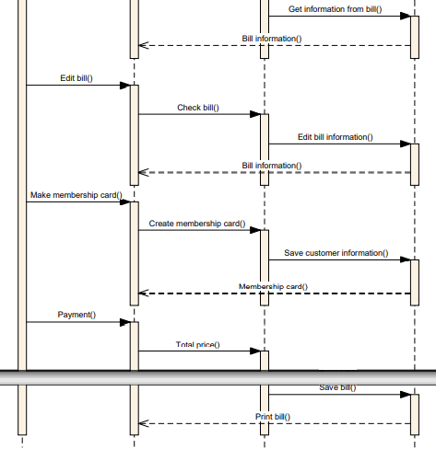

***Figure8. Cashier sequence diagrams.***

1. ***CLASS DIAGRAMS***

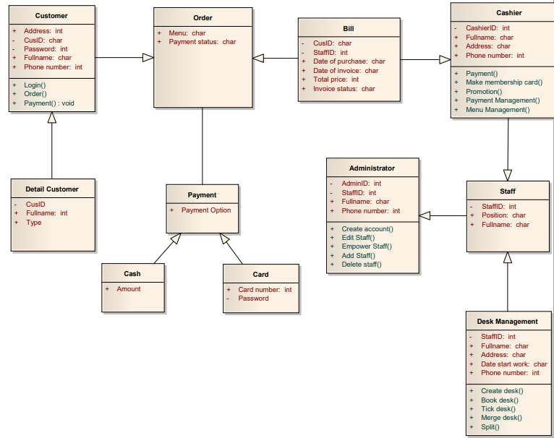

***Figure9. Class diagrams.***

1. ***COMMUNICATION DIAGRAMS***
2. 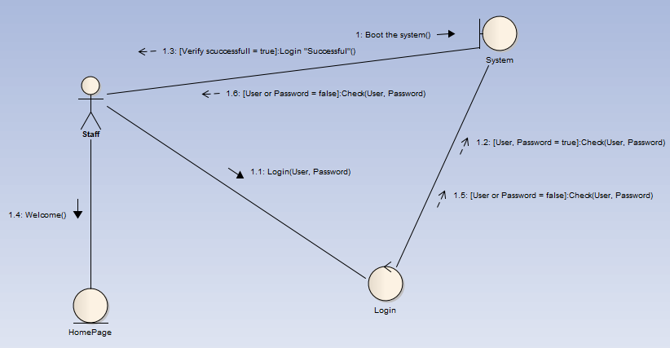***Login:***

***Figure10. Login communication diagrams.***

1. 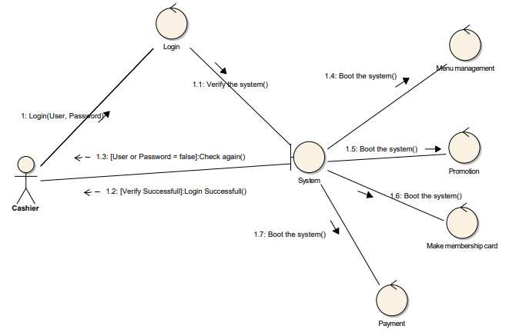***Cashier:***

***Figure11. Cashier communication diagrams.***

1. ***STATE DIAGRAMS***
2. ***Login:***

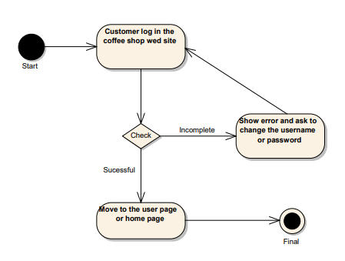

***Figure12. Login state diagrams.***

1. ***Staff management:***

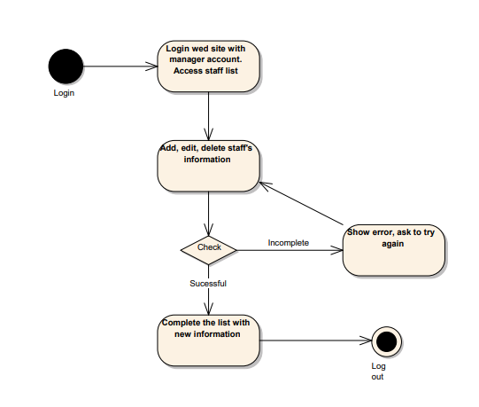

***Figure13. Staff management state diagrams.***

1. ***COMPONENT DIAGRAMS:***

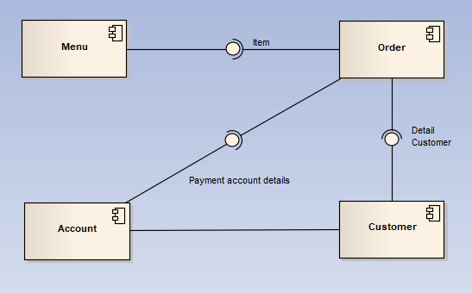

***Figure14. Customer component diagrams.***

1. ***SUMMARY:***

We have completed the project quite a lot of diagrams. Through the diagrams can help people who want to use this application understand easily. Customers can add other features to improve the website in the next versions.

The diagrams are detailed, detailed content. In later versions, the Coffee shop management system will have more upgraded functions and can be distributed to many shop owners to use the website when needed.